HERstory
The Open Book Press
March 2017

Welcome!
Thanks for picking up a copy of the RAD DADS zine. In light of recent events, the Open Book Press will be developing a new zine distinct from Yuba Lit, one specifically concerned with (and inspired by) the current social climate and examined through poetry, fiction, nonfiction, and the arts. We will continue to collaborate with Yuba Lit speakers as well as writers and artists within the community and beyond. Look for our new name, design, and content soon!
The Open Book Press is the new publishing division of the Open Book bookstore, 671 Maltman Drive in Grass Valley.
To submit your work for consideration, please e-mail info@theopenbookgv.com
A word is dead
When it is said,
Some say.
I say it just begins
to live that day.
– Emily Dickinson

© 2017: Unless otherwise expressed, copyright is retained by contributing author. Cover art by Jenny Godwin.

- Contributors –
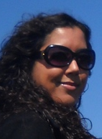
Angela Sells, PhD, is a mythology and poetry instructor at Sierra College and Meridian University. She is an emerging author, with her first book, Sabina Spielrein; The Woman and the Myth, due out in 2017 with SUNY Press. She is the Co-Founder of the Open Book Press and the Co-Producer of Yuba Lit. She is the editor of this zine.
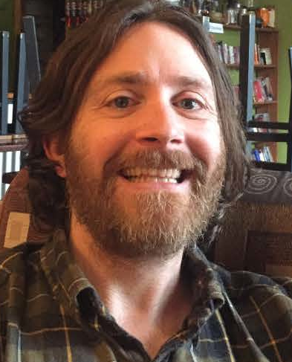 Will Dane earned a bachelor's in English with a minor in Creative Writing and a master's in Professional Writing at the University of Massachusetts Dartmouth. He teaches a short fiction workshop through OLLI. His current novel in progress is closely based on his experiences raising a teenage son and finding new true love in the modern age.

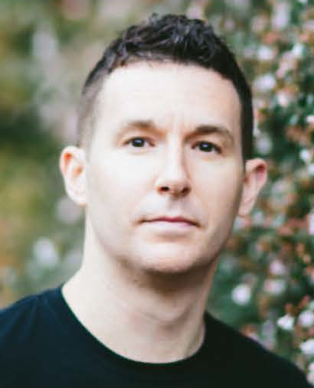 Joshua Mohr’s memoir Sirens traces his
childhood swilling fuzzy navels as a latch-key kid to
his own parenthood and surgery to fix the literal
hole in his heart. "An entirely candid, compelling
memoir of addiction and the long, fraught road of
recovery" (Kirkus), it's also a testament to the
transforming power of fatherhood.

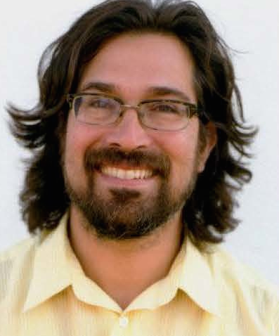Oakland writer Tomas Moniz is the editor of
the award winning zine Rad Dad, whose anthology
Rad Families: A Celebration honors the messy, the
beautiful, the myriad ways we create families with
stories from a diverse group of parent-writers
willing to be vulnerable. Moniz is also the author of
a novella, Bellies and Buffalos.
JOSHUA MOHR Q&A
How did writing become your vocation?
I was born with this writing sickness! It’s a total compulsion, something I do daily and derive so much pleasure from—and that’s key for me. I’ve engineered a writing life that’s fun. I always tell people if you follow the fun, it will very rarely lead you astray.
Do you have any particular writing rituals?
I don’t believe in writing rituals, as often they become “tools” for procrastination. I believe in showing up every day, working on my craft. I do, however, write two books at the same time, so I can never use writer’s block as an excuse. If I get stuck in one, I pop over and work on the other.
Your memoir, Sirens, details your past as being involved with heavy drug use and drinking, though parenthood drastically altered your behavior. When writing a memoir with sensitive material like this, do you think about what kind of conversations will arise later in life with your daughter?
Hopefully, conversations that are incredibly honest. I wrote this memoir as a love letter to her, as I was approaching heart surgery. I wanted to leave a record for her, just in case I died on the operating table.
Perhaps dovetailing off of the last question; how has fatherhood affected your writing?

Oh my gosh, fatherhood has tried to kill my writing! I’m kidding. Sort of. It’s certainly harder to make the time to write. I drink a lot of espresso. Like, it’s crazy how much caffeine I intake. But I’m a firm believer that it’s no one else’s job to prioritize our art. We have to make the time. We have to honor our process!
Has there been anything about parenthood that has occurred as expected?
No, not really. You learn stuff and then the kid is onto a new phase, and you have to learn entirely new lessons. That’s the great fun and the great frustration in the whole process. I love being a dad. If I was rich, I’d have 3951 children.
Thank you for your time!
TOMAS MONIZ Q&A
Not only is this Yuba Lit evening’s title in homage of your Rad Dad magazine, but your short bio relays: “Tomas Moniz writes about parenting, makes zines of short fiction, performs randy poetry, organizes and hosts events, teaches community college and loves to mingle.”
Wow! Can you start by telling me a bit about your background and how you became a writer?
I began writing to find community and help as a young parent. I loved zines and the diy aesthetic of trusting your own voice and creating your own art, so I started making zines about being a young father and then my writing kept evolving.
What exactly is “randy poetry”?
Randy poetry oftentimes leads to rad parenting! Just kidding; it's playful, vulnerable, bodily, honest explorations of desire.
What inspires you about the genre of short fiction?
That I could do it between helping kids with homework and making dinner.
Do you have any particular writing rituals?

Persistence: Sit. Avoid social media. Write.

How has fatherhood affected your writing?

I was a father before I started writing.

Has there been anything about parenthood that has occurred as expected?

That it’s made me a better human. More kind. More loving.

Has being a father changed how you view the impact of politics in today’s current social climate?

It’s made me a feminist and a radical. How can anyone think sexisim and racism aren’t key issues affecting young people in our society, people just like our own daughters and sons.

Last, but not least: would you like to share a poem or short piece of writing for our readers?

Here’s a new poem from my manuscript on unpacking masculinity.

fathersong #1

son you made me cocky

the arrogance to carry you
at 21
strapped to my chest
ajax with shield
on public busses to & from
school

i imagined myself babyholding warrior
fearing that to the young
men & women
riding next to me i was
anomaly & sacrilege
& ugly

but truth be told
nothing was more lovely than

your fat legs dangling
down & never shoed

when reproached by old ladies
holding plasticbags & gaptoothed smiles
to keep your feet warm

i nodded yes
but whispered to you

don’t worry
we run hot
& together
we are weapon

*Editor’s Note: I [A.S.] was moved to tears after reading this. How beautiful.
WILL DANE
[On fatherhood (from novel-in-progress]
Wally’s feelings are opaque but at least grunting toward the Dad; completely closed off from Angel. He’s never had a bad word to say about her, the only negative expression being the birthday party snub, and they’ve had plenty of fun moments at my expense. But there are also times like these [in San Francisco for the weekend], when I feels like I’m on two different trips, with two different people, at the same time. In a North Beach diner for brunch, Wally can’t be convinced to try a bit of mimosa or even orange juice, washing down his scowling plain toast with milk.
[A poem on love]
Fire within the container of you
old and enduring fuel
touchy thermostat
the fan of my inadvertant words
Sparks—contained conflagaration
Out of rips in the foil seep
Blinding heat, blinding light.
Wearing goggles and welding apron, I
toss you a notebook and pen:
slash through that forest of words
a firey ink mess
resolving
downthepage
into readable emotion.
You glance up strong and cooled
Our love is alchemically strong
like gold
Even heated close to melting
It forms up again, subtly reshaped
Like the bottles my friends used to smash
into a fire pit in an Oregon forest
the glass shards re-formed
into bizarre Dali-esque lumps
every pine-shadow sun-drenched morning.
Now, even when chipped or cracked,
we throw the bit back in
push it together by hands
weld it with lovemade sweat
—our hungry consuming mouths
sizzling fused skin
—nipples clit head of cock within.
We sleep wrapped up.
Steeping mate in the morning
smelling like pine smoke

THANK YOU FOR READING
